**Abstract**

This abstract presents an overview of an automatic boiler system designed and implemented using Mitsubishi Programmable Logic Controller (PLC) technology. Boilers are critical industrial devices used for generating steam or hot water for various applications. Automation of boiler systems enhances efficiency, safety, and operational control. The integration of Mitsubishi PLC technology provides a reliable and sophisticated solution for achieving these goals.The automatic boiler system employs Mitsubishi PLCs to control and monitor various aspects of the boiler operation. The system consists of sensors, actuators, control logic, and a pump. Sensors continuously gather data on parameters such as temperature, pressure, and water level. This real-time data is processed by the Mitsubishi PLC, which then executes control algorithms based on predefined logic.

**CHAPTER ONE**

**1.0 INTRODUCTION**

**1.1 BACKGROUND OF THE STUDY**

The industrial sector relies heavily on energy sources, with steam being a crucial utility for various processes, including heating, power generation, and chemical reactions. Boilers play a pivotal role in producing steam, making them essential components of industrial facilities. To optimize energy consumption, operational efficiency, and safety, the integration of programmable logic controllers (PLCs) into boiler systems has become a prevalent trend.

Boiler systems are complex and critical components in various industries. Manual operation of boilers can lead to inefficiencies, safety hazards, and increased energy consumption. Automation aims to address these challenges by enabling continuous monitoring, precise control of parameters (such as temperature, pressure, and fuel input), and timely adjustments to ensure optimal performance.

Industrial automation has revolutionised manufacturing processes by introducing advanced control systems that streamline operations, enhance precision, and reduce human intervention. PLCs are at the heart of industrial automation, providing real-time control, monitoring, and data processing capabilities. They are particularly well-suited for applications requiring repetitive, precise, and complex control sequences, making them an ideal choice for managing boiler systems.

Mitsubishi Electric is renowned for its advanced PLC technology, which offers high-performance control, exceptional reliability, and user-friendly programming interfaces. Mitsubishi PLCs are equipped with various communication protocols, digital and analog I/O modules, and the capacity to interface with human-machine interface (HMI) systems. These features make Mitsubishi PLCs a suitable choice for building sophisticated and efficient boiler control systems.

**1.2 AIM AND OBJECTIVES OF THE STUDY**

**Aim**

The aim of the Boiler System using PLC is to design, develop, and implement an automated and efficient boiler control system utilizing Programmable Logic Controller (PLC) technology. The primary goal is to enhance the operational efficiency, safety, and reliability of the boiler system while minimizing energy wastage and human intervention.

**Objectives:**

The objectives of the Boiler System using PLC project are as follows:

1. Automated Control:Develop a control system that automates the operation of the boiler, including ignition, heat input regulation, water level control, and pressure regulation, using Mitsubishi PLC technology.

2. Safety Integration: Implement safety protocols and interlocks using PLC logic to respond to abnormal conditions, such as high pressure or low water levels, ensuring the safe operation of the boiler and preventing potential hazards.

3. Fault Detection and Diagnostics: Develop algorithms within the PLC to detect and diagnose faults, anomalies, and operational irregularities, providing maintenance personnel with actionable insights for prompt troubleshooting.

4. Adaptive Operation: Design the PLC control system to adapt to varying loads and operational conditions, ensuring optimal performance across different production scenarios without manual intervention.

5. Documentation and Training: Develop comprehensive documentation for the PLC-based boiler system, including operation manuals, maintenance guides, and training materials to ensure proper system understanding and management.

6. Integration with Existing Infrastructure: Integrate the PLC-based boiler control system seamlessly with the existing plant infrastructure, ensuring compatibility and minimizing disruption during installation and commissioning.

7. Performance Validation: Conduct thorough testing and validation of the PLC control system under various operating conditions to ensure that it meets the specified performance criteria and objectives.

By achieving these objectives, the project aims to create a state-of-the-art Boiler System using PLC technology that not only enhances the efficiency and safety of boiler operations but also contributes to reduced energy consumption, improved product quality, and operational excellence in industrial settings.

**1.3 Scope and Limitation**

The scope of the Mitsubishi PLC-based automatic boiler system encompasses various aspects of design, implementation, operation, and benefits. The system aims to revolutionize boiler operations by leveraging Mitsubishi's advanced PLC technology to enhance efficiency, safety, and control in steam generation processes. The following outlines the key components of the system's scope:

**System Design:**

- Development of a comprehensive control strategy for automated boiler operation.

- Selection of appropriate Mitsubishi PLC hardware and peripherals for the system.

- Integration of safety interlocks and protocols to prevent hazardous conditions.

**Automation and Control:**

- Implementation of PLC-based algorithms for real-time control of boiler parameters, such as temperature, pressure, and heat input.

**Safety Enhancement:**

- Incorporation of safety interlocks and emergency shutdown protocols to prevent dangerous situations.

- Implementation of alarms and notifications to alert operators about abnormal conditions.

- Integration with safety systems to ensure compliance with industry standards and regulations.

**Integration and Scalability:**

- Evaluation of compatibility with existing control systems and potential for integration.

- Consideration of system scalability to accommodate future expansions or modifications.

**Limitations of Mitsubishi PLC-Based Automatic Boiler System:**

* Initial Investment: Implementing the system involves upfront costs for Mitsubishi PLC hardware, programming, and system integration. The initial investment might be a barrier for some organizations.
* Complexity: Designing and programming a PLC-based system requires expertise and time. Complex algorithms and interlocks need careful consideration and testing to ensure optimal performance.
* Maintenance and Support: While PLC systems are generally reliable, maintenance and technical support are necessary to address potential hardware or software issues that may arise over time.
* Human Intervention: While the system minimizes human error, it still requires skilled personnel for maintenance, troubleshooting, and occasional manual intervention.
* Process Complexity: While the system can handle many boiler operations, extremely complex processes may require additional specialized control systems.
* Dependence on Technology: The system's performance relies on the reliability of Mitsubishi PLC technology. Technical advancements or changes to the technology could impact the system's long-term viability.
* Training: Operators and maintenance personnel need appropriate training to effectively operate and maintain the system.

**1.4 BENEFITS OF THE STUDY**

The study of a Mitsubishi PLC-based boiler system brings forth a multitude of benefits that positively impact industrial operations, safety, efficiency, and sustainability. It offers a compelling case for adopting advanced automation solutions to enhance boiler operations in modern industrial settings.

**1.5 RESEARCH QUESTION**

1. How do you use a Mitsubishi PLC?
2. What is PLC Mitsubishi?
3. What software does Mitsubishi PLC use?

**1.6 APPLICATIONS OF THE STUDY**

The areas of application of this device are as below:

* Power Generation Plants
* Chemical Industry
* Food and Beverage Industry
* Textile Industry
* Oil and Gas Industry
* Automotive Industry
* Hospital and Healthcare Facilities
* HVAC Systems
* Renewable Energy
* Textile and Garment Industry

**CHAPTER TWO**

**2.0 LITERATURE REVIEW**

## 2.1 **REVIEW OF RELATED STUDIES**

**Chandrashekar S.G., Dr. K.V. Mahendra PrashanthMarch 2015,** depicts the utilization of PLC for the checkingand filling of tablets for pharmaceutical application. Theygives the contrast between utilization of small scale controllerand PLC as miniaturized scale controllers are less adaptable toelectrical clamor, vibration, and temperature. What's more,PLC is made for various simple and advanced information,yield, better in broadened temperature extents, clamor andvibration. They clarified the point by point procedure of theirframework. The venture is isolated into two sections 1.Equipment plan and 2. Programming plan. In which everysegment measurement and determination are given. Theyutilized three metal adapted 24 V DC ,DC motor which hasevaluated torque - 15 kg-m and appraised speed – 15 rpm,current – 0.5A.PLC utilized is Rexroth Indra Logic L 20Bosch gathering and IR sensors utilized of 5V DC to identifythe compartment. 4 no. transfers utilized 3 of 24 V DC and 1of 5 V DC. The framework gave more accuracy and lesswastage of tablets.

**Mallaradhya H.M., K.R.** Prakash Oct-2013, they builtup an arrangement of programmed bottle filling of varioustallness through PLC coordination. Amid their examinationthey characterized the issue which is to be settled i.e. there areframework no one but which can fill a specific heighted holderand subsequent to discovering they construct one. As normalutilized three capacitive sorts of Proximity sensor sensors, ACsynchronous DC motor, and solenoid valve. For the wellbeingof PLC yield of sensors is not straightforwardly given to thePLC firstly it is flag adapted circuits by utilizing transferswhich comprises three terminals normal, NO and NC. Withrespect to yield gadgets from PLC utilized transfer drive unitconcerning DC motor input voltage is 12 V. The filling ofholder is just in view of the planning of the solenoid valve sofor the filling distinctive size compartment they change timingin the program

**Bhise et al (2015)** proposed an embedded PLC for teaching students. Authors combined LabVIEW software and the AVR Microcontroller with the VB modules to achieve the embedded PLC built bottle filling plant for it application. The programming language used for the embedded PLC is the FB. Although the embedded PLC setup is flexible, relatively easy and affordable to teach the basic principle for PLCs, they did not present or discuss FB program for the bottle filling application. Also, survey report of their application shows moderate performance in stability and reliability.

**Mahadi et al (2015)** proposed a PLC Trainer Kit Simulator Automation Lab at the Polytechnic of Sultan Abdul Halim Mu’adzam Shah (POLIMAS). The training kit comprises the Omron PLC CPU unit with 12 inputs and 8 outputs control. Input and output devices are bank of switches and light indicators respectively. They used CX- Programmer for CP1E version 1.0 to program the PLC using ladder diagram and instruction list PLC programming languages. The fabrication of a multiple input/output (I/O) PLC module for educational purpose to enhance the learner’s theoretical comprehension and hands-on skill especially for programming, cabling, circuit design and problem solving according to Ibrahim et al (2015). Their module consists of I/O devices such as push buttons (normally open), DC motor (24V), DC relay (24V), DC solenoid piston cylinder (24V) and DC light (24V) capable of interfacing with PLC controller produced by Matsushita, Omron, Siemens. Survey report from the trainees show that 95.70 % attest to the enhancement in their theoretical comprehension and hands-on skill competence in their learning process.

**Sukir et al (2019)** proposed a PLC Based Electrical Machine Trainer Kit developed for Electrical Engineering Practices in the Department of Electrical Engineering Education at Faculty of Engineering, Universitas Negeri Yogyakarta. Their approach is research and development with reference to the ADDIE model from RobertMaribe Branch. The installed PLC is Zelio SR2.201FU and the console dimension is 44.1 cm ×100 cm and 92.7 cm ×100 cm with a front tilt angle of 80 °. Authors examined the performance of trainer kit on 8 practical experiment; rotation control of DC motors; rotation control of three phase induction motor; rotation control of one phase induction motor; starting DC motor; starting 3 phase induction motor using auto-transformer; dynamic DC motor braking; DC motor braking by plugging; and braking 3- phase induction motor by DC injection. Result show the trainer kit has a good performance, indicated by the electrical components and the practical work description can function appropriately as planned. They used the Delta DVP14SS2 PLC, WPLSoft software and switches as inputs and pilot lamps as outputs. Instructors trained student on cabling and programming of PLC with hands-on training on Traffic light automation application. Authors carried out pre and post training evaluation for trainee and result show significant improvement of about 45.8% in the trainees’ capacity to wire and program a PLC for automation control.

**Samanol et al (2014)** analyze "Development of pneumatic trainer kits for polytechnic students," which produces pneumatic trainer kits for learning the basics of pneumatics for students of the Department of Engineering, Seberang Perai Polytechnic, Malaysia. These studies differ from this particular research, in terms of trainer kit products and use.

Related to research on Programmable Logic Controllers (PLC), **Akparibo John (2016)** conducted a study entitled "Development of a programmable logic controller training platform for the industrial control of processes." The research obtained an interactive, cheaper and more portable PLC trainer kit for industrial process control simulations. The PLC Trainer kit

## 2.2 Block Diagram of the system

Power Supply

Mitsubishi

PLC

Temp

Sensor

Level Sensorr

Pump

Heater

**Power Supply Unit :**

Designing a 24V DC power supply involves creating a circuit that takes in an input voltage (usually from the AC mains 220v) and converts it into a stable 24V DC output.

Components Needed:

* Transformer: Converts high-voltage AC input from the mains to a lower-voltage AC.
* Rectifier: Converts the step down AC to pulsating DC.
* Filter Capacitor: Smoothens the pulsating DC into a more constant DC voltage.
* Voltage Regulator: Stabilizes the DC voltage to 24V.
* Output Capacitor: Further filters the output voltage for reduced ripple.
* Protection Circuitry: Includes components like fuses and protection diodes for safety.

**Temperature transmitter Unit**

A temperature transmitter is a device used to measure temperature and convert it into a standardized output signal that can be used for monitoring, control, and communication purposes. It's commonly used in industrial processes and automation systems where accurate temperature measurement and control are critical.

**The Mitshibushi PLC Unit:**

Mitsubishi Electric is a well-known company that manufactures a wide range of automation and control products, including Programmable Logic Controllers (PLCs). Mitsubishi PLCs are widely used in industrial automation for controlling processes, machinery, and equipment. They offer various series and models of PLCs designed to suit different application requirements.

Mitsubishi PLC Features and Components:

- CPU (Central Processing Unit):The CPU is the brain of the PLC. It processes logic and executes control functions based on the program loaded into it.

- Digital and Analog Input/Output Modules:These modules interface with sensors, switches, actuators, and other devices in the field.

- Communication Modules:Mitsubishi PLCs support various communication protocols for connecting with other devices, networks, and control systems.

- Programming Software:Mitsubishi PLCs are programmed using software such as GX Works3 or GX Developer. These software tools offer a user-friendly interface for creating, testing, and debugging ladder logic or other programming languages supported by the PLC.

- HMI Integration: Mitsubishi PLCs can be integrated with Human-Machine Interfaces (HMIs) for creating visual interfaces to interact with the control system.

- Safety Functions:Some Mitsubishi PLC models include safety features that enable safe operation in industrial environments. These safety functions can include emergency stops, safety interlocks, and more.

- High-Speed Counting and Positioning: Mitsubishi PLCs can handle applications requiring high-speed counting and precise positioning, making them suitable for motion control tasks.

**Level Sensor Unit:**

A conductivity level sensor is a type of level measurement device used to determine the level of a liquid or substance within a container or tank based on its electrical conductivity. It operates by detecting changes in the electrical conductivity of the liquid, which is influenced by the concentration of dissolved ions or particles within the liquid.

The "two point" aspect of this sensor refers to the two predefined conductivity levels at which the sensor triggers specific actions or measurements. These levels are typically categorized as low level, and high level. When the liquid reaches each of these levels, the sensor responds in a certain way, often by activating alarms, control systems, or pumps.

Here's how the two-point conductivity level sensor generally works:

1. Low Level: When the liquid level drops to the low level point, the conductivity sensor detects a decrease in electrical conductivity. This could be due to the fact that less of the liquid is in contact with the sensor's electrodes, leading to a weaker electrical signal. This trigger might initiate actions like activating a pump to refill the tank.

3. High Level: When the liquid level reaches the high level point, the electrical conductivity is at its highest, as more of the liquid is in contact with the electrodes. This trigger can lead to actions such as shutting off a filling process or activating an overflow alarm to prevent spillage.

**Heating Unit:**

A heater unit is designed to generate heat and raise the temperature of the process boiler, the heater is controlled by the PLC automatically when the temperature of the process heats a certain setpoint.

## 2.3 Review of Components of the system

2.3.1 The Programmable Logic controller (PLC)

Programmable Logic Controllers continuously monitors the input values from various input sensing devices (e.g. accelerometer, weight scale, hardwired signals, etc.) and produces corresponding output depending on the nature of production and industry. A typical block diagram of PLC consists of five parts namely:

1. Rack or chassis
2. Power Supply Module
3. Central Processing Unit (CPU)
4. Input & Output Module
5. Communication Interface Module

### Rack or Chassis

In all PLC systems, the PLC rack or chassis forms the most important module and acts as a backbone to the system. PLCs are available in different shapes and sizes. When more complex control systems are involved, it requires larger PLC racks.

Small-sized PLC is equipped with a fixed I/O pin configuration. So, they have gone for modular type rack PLC, which accepts different types of I/O modules with sliding and fit in concept. All I/O modules will be residing inside this rack/chassis.

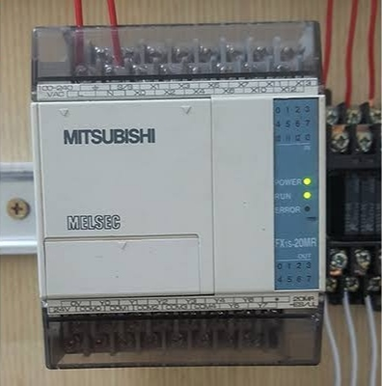

fig 2.1: Pictorial representation of PLC

### Power Supply Module

This module is used to provide the required power to the whole PLC system. It converts the available AC power to DC power which is required by the CPU and I/O module. PLC generally works on a 24V DC supply. Few PLC uses an isolated power supply.

### CPU Module and Memory

CPU module has a central processor, ROM & RAM memory. ROM memory includes an operating system, drivers, and application programs. RAM memory is used to store programs and data. CPU is the brain of PLC with an [octal](https://www.electrical4u.com/binary-to-octal-and-octal-to-binary-conversion/) or hexagonal microprocessor.

Being a microprocessor-based CPU, it replaces timers, relays, and counters. Two types of processors as a single bit or word processor can be incorporated with a PLC. One bit processor is used to perform logic functions. Whereas word processors are used for processing text, numerical data, controlling, and recording data.

CPU reads the input data from sensors, processes it, and finally sends the command to controlling devices. DC power source, as mentioned in the previous discussion is required voltage signals. CPU also contains other electrical parts to connect cables used by other units.

### Input and Output Module

Have you ever thought about how to sense physical parameters like temperature, pressure, flow, etc? using PLC? Of course, PLC has an exclusive module for interfacing inputs and output, which is called an input & output module.

Input devices can be either start and stop pushbuttons, switches, etc and output devices can be an electric heater, valves, relays, etc. I/O module helps to interface input and output devices with a microprocessor.

* **TYPES OF PROGRAMMABLE LOGIC CONTROLLER**

The two main types of PLC are fixed / compact PLC and modular PLC.

### **Compact PLC**

Within a single case, there would be many modules. It has a fixed number of I/O modules and external I/O cards. So, it does not have the capability to expand the modules. Every input and output would be decided by the manufacturer.

### Modular PLC

This type of PLC permits multiple expansion through “modules”, hence referred to as Modular PLC. I/O components can be increased. It is easier to use because each component is independent of each other.

PLC are divided into three types based on output namely Relay output, Transistor output, and Triac Output PLC. The relay output type is best suited for both AC and DC output devices. Transistor output type PLC uses switching operations and used inside microprocessors.

According to the physical size, a PLC is divided into Mini, Micro, and Nano PLC. Some of the manufacturers of PLCs include:

1. [Allen Bradley](https://ab.rockwellautomation.com/Programmable-Controllers/ControlLogix/5580-Controllers)
2. [ABB](https://new.abb.com/plc/programmable-logic-controllers-plcs)
3. [Siemens](https://new.siemens.com/global/en/products/automation/systems/industrial/plc.html)
4. [Mitsubishi PLC](https://www.mitsubishielectric.com/fa/products/cnt/plc/index.html)
5. [Hitachi PLC](https://www.hitachi-ies.co.jp/english/products/plc/index.htm)
6. [Delta PLC](https://www.deltaww.com/Products/CategoryListT1.aspx?CID=060301&PID=ALL&hl=en-US)
7. [General Electric (GE) PLC](http://www.geautomation.com/products/programmable-automation-controllers%EF%BB%BF)
8. [Honeywell PLC](https://www.honeywellprocess.com/en-US/explore/products/control-monitoring-and-safety-systems/scalable-control-solutions/Pages/masterlogic-plc.aspx)

## PROGRAMMING A PLC

When using a PLC, it’s important to design and implement concepts depending on your particular use case. To do this we first need to know more about the specifics of PLC programming.

A PLC program consists of a set of instructions either in textual or graphical form, which represents the logic that governs the process the PLC is controlling. There are two main classifications of PLC programming languages, which are further divided into many sub-classified types.

1. **Textual Language**
   1. Instruction list
   2. Structured text
2. **Graphical Form**
   1. Ladder Diagrams (LD) (i.e. Ladder Logic)
   2. [Function Block Diagram](https://www.plcacademy.com/function-block-diagram-programming/) (FBD)
   3. Sequential Function Chart (SFC)

Although all of these PLC programming languages can be used to program a PLC, graphical languages (like ladder logic) are typically preferred to textual languages (like [structured text programming](https://www.plcacademy.com/structured-text-tutorial/)).

### Ladder Logic

[Ladder logic](https://www.plcacademy.com/ladder-logic-tutorial/) is the simplest form of PLC programming. Ladder logic has evolved into a [programming language](https://en.wikipedia.org/wiki/Programming_language" \o "Programming language) that represents a program by a graphical diagram based on the [circuit diagrams](https://en.wikipedia.org/wiki/Circuit_diagram" \o "Circuit diagram) of [relay logic](https://en.wikipedia.org/wiki/Relay_logic" \o "Relay logic) hardware. Ladder logic is used to develop software for [programmable logic controllers](https://en.wikipedia.org/wiki/Programmable_logic_controller" \o "Programmable logic controller) (PLCs) used in industrial control applications. The name is based on the observation that programs in this language resemble [ladders](https://en.wikipedia.org/wiki/Ladder" \o "Ladder), with two vertical rails and a series of horizontal rungs between themIt is also known as “relay logic”. The relay contacts used in relay controlled systems are represented using ladder logic (Edward, 2019). The below figure shows a simple example of a ladder diagram.

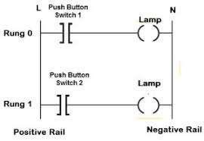

Fig 2.1 PLC Ladder Logic

In the above-mentioned example, two pushbuttons are used to control the same lamp load. When any one of the switches is closed, the lamp will glow.

The two horizontal lines are called rungs and the two vertical lines are called rails. Every rung forms the electrical connectivity between Positive rail (P) and Negative rail (N). This allows the [current](https://www.electrical4u.com/electric-current-and-theory-of-electricity/) to flow between input and output devices.

**CHAPTER THREE**

**3.0 METHOD OF ANALYSIS**

With the need for a design of a steam production control process, we shall in this chapter analyze the components which will be required for this design and construction and also the specifications which they shall need to meet for the success of this project.

With the constraint of this project lying on its requirements for a fair knowledge of software engineering especially on the area of programming. A grounded knowledge of process control alongside A fair knowledge of panel wiring is also important together with Digital and analogue input/output and their conversions.

It is also necessary in the design of this project that certain requirements are taken into consideration, for instance:

i. Safety.

ii. Production/Running cost.

iii. Interfaces to a PC and possibly HMIs.

iv. Compatibility with common industrial electrical components.

In this project work, we shall be designing and eventually constructing a PLC based automatic boiler using the Mitsubishi FX2N-32MT which would be used in the Instrumentation Laboratory of the Petroleum Training institute for the purpose of simulating steam production control process.

To achieve success of this design work, it is extremely important that we consider each component in depth especially with regards to its power requirements and its compatibility with other components which we shall be using in the construction of this project work. We shall also be paying keen attention to safety and cost in our assessment of the components and their eventual selection.

**3.1 DESIGN SPECIFIFCTIONS**

The design of this PLC based level control system has the following components:

1. The power supply unit.
2. The controller unit.
3. The conductors.
4. The Heater.
5. The Pump.
6. The Level Sensor.
7. The programming/Simulation.

**3.2 DESIGN CONSIDERATION OF EACH COMPONENT**

Considering the vast range of components available in the market with varying specifications. It has become of extreme importance we pay keen attention to ensure that components selection is done with not just safety and power requirements but also its compatibility with every other component we shall be using. With that in mind and with the knowledge of our desired output which is a training kit, we shall move ahead to detail the steps taken in the selection of our various components.

**3.3 TOTAL CURRENT REQUIREMENT**

It is of great importance that we make the selection of our components with keen attention to their power requirements. We shall have to understand the individual current requirement for the components and this shall be applied to determine our overall current requirement. Having this knowledge will be very helpful also in the selection of our power supply unit.

Current rating of the pump:3450mA

Current rating of the heater:6000mA

Current rating of the controller: 500mA

Current rating of Lamp: 1.5mA = 1.5mA

Current rating of Temperature sensor: 5.5mA = 5.5mA

Current rating of Level sensor: 1.8mA = 1.8mA

Total current = 9,958.8mA

**3.4 THE POWER SUPPLY UNIT**

The power supply was chosen to meet the requirement of supplying current to the entire system as no component of the system will be powered externally. The following specifications were used in the selection of the power supply:

Number of power supply: 1

Nominal input voltage: 220/240 VAC

Frequency: 50Hz

Output voltage: 110/220VAC

Factors considered in selecting the above output voltage: include the PLC input voltage, the Heater voltage requirements (220VAC) and the Pump voltage (110VAC). Since all voltages are equal, we choose the 110/220VAC output.

Output Power: 2199 watts

The output power was selected based on the power requirements of the various components used. The calculation for the output power can be found under each component.

**3.5 THE CONTROLLER UNIT**

For the purpose of this project, we shall be using the MITSUBISHI FX2N-32MT PLC as our controller. This component will be responsible for the control of all the components of the project which ranges from turning ON/OFF the process pump to control level to activating the LAL and LAH in case of system failures.

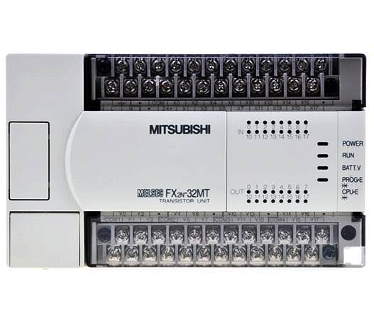

Figure 3.1 Pictorial diagram of the PLC

The PLC has the following specifications:

Number of PLC: 1

Dimension (W x H x D) mm: 150 x 90 x 87

Number of inputs: 24

Number of outputs: 16(Transistor)

Output type: Transistor

PLC Input voltage : 100 - 240 VAC

PLC Programming Interface: Computer

Operating current: 500mA

Input frequency: 50Hz

Power requirements: P=I x V

V=240V

I=500Ma/1000=0.5A

P=0.5x240

P=120watts

Connection cable: 2*1.5mm2

Programming Language: Ladder Logic

External memory module: Not Available

Program Capacity: 8000 Steps

**3.6 THE CONDUCTORS**

It is of extreme importance that the proper conductor sizing is selected. To achieve this, we would have to pay attention to the load requirement of the entire system.

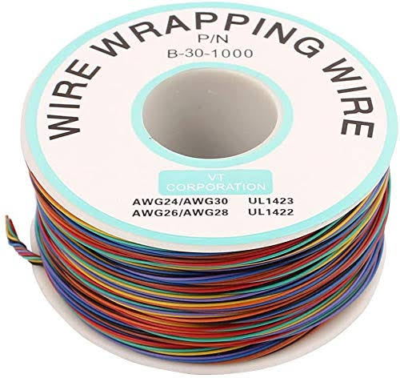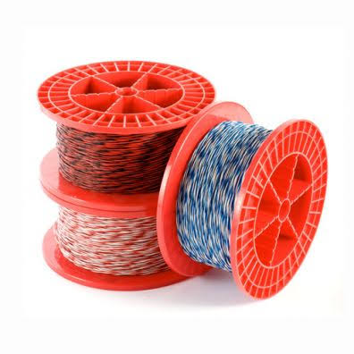

Figure 3.2 Diagram of the conductors (jumper wires)

The conductors shall be selected with respect to the following specifications.

Number of cables: 24

Voltage Requirement: 110/220VAC

Current Capacity: 200watts

Cable Lengths: 2mm2

**3.7 THE INDICATOR LAMPS**

These components shall be used in the automatic boiler to indicate the process going on in the process. It shall be designed to indicate the moment the system is turned ON, the level of process fluid in the process tank, the process of the controller (PLC) in the control of level in the process tank. There shall also be designated Lamps to indicate faults such as overflow in the process tank.

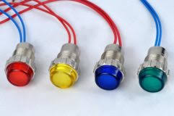

Figure 3.3 Diagram of the indicator lamps

The selection of the Lamps shall be based on the following specification:

Voltage Requirement: 110/220 VAC

Current Requirement:1.5mA

Dimensions: 3.46 × 2.72 × 1.02 inches

Mounting hole size: 8mm

Color: Red, Yellow and Green.

**3.8 THE SWITCHES**

For the purpose of this project work, we shall be considering the Push button switches. These are switches which are pushed to either activate or deactivate them. As they are going to be very important component of the project and shall serve to complete/connect or disconnect a circuit to start or stop a process. With the wide range of options in the market, it is very important we pay special attention in their selection.

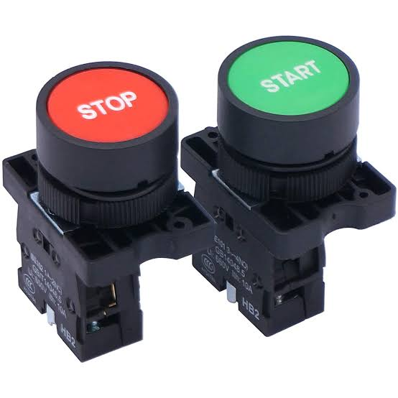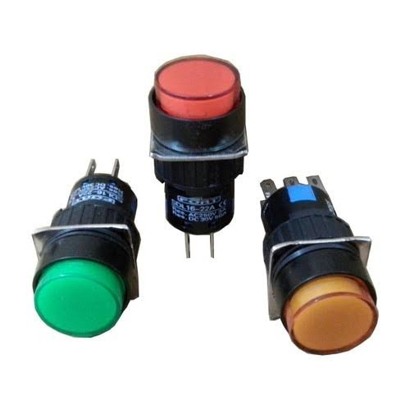

Figure 3.4 Diagram of the switches.

The following criteria shall be considered in the selection of our switches.

Voltage Requirement: 110VAC

Current Requirement: 1000mA

Number of Pins: 2

Colour of switches: Red and Black

Model of switches: Normally Open

Depth of switches: 16mm

Length of switches: 25mm

**3.9 THE HOUSING STRUCTURE**

This is the part of the project that shall serve to house (contain) the entire components being used in the construction of this project work. It is of utmost importance that we consider cost, mobility and material strength in selecting the material for our housing structure. The following requirements were considered in the selection of our housing structure:

1. Cost of the material to be used.
2. Strength of the material.
3. Durability of the material.
4. Ease of fabrication of the material.

Having considered the above points, we have decided to select metal as our most desired housing material. We shall be fabricating in the best possible way to economize space and also neatly contain all the components of the automatic boiler.

The sizing of the structure shall be designed to meet the below specification:

Width:

Height:

Area:

Length:

**3.10 THE SOFTWARE DESIGN**

In the software design of our automatic boiler control process, we shall be using a personal computer and Ladder Logic programming software (GX Developer) to write a ladder logic program which would be used to simulate the control process. This part is made up of two major structures which must be treated properly to ensure the success of this project work. They are:

#### ALGORITHM GENERATION

An algorithm is a statement of the procedure adopted in solving a problem. The supposed sequence of the system operation is stated below:

1. Powering ON of the boiler.
2. Powering ON/Booting of the Personal Computer.
3. Starting up of the GX Developer and running of the program.
4. Simulation of the Boiler Control process.
5. End of the process.
6. **FLOW CHART**

This is basically a chart that uses graphical representation to describe the proposed sequence of operation of this training kit.

Figure 3.5 Diagram of the entire system’s flow chart

**3.11 THE PROGRAMMING/SIMULATION**

In this part of the project work, we shall be using the Ladder Logic programming Language to write a program which would be applied to our project to simulate the control process. It is important to note that in the simulation of this project work, different programs can be written to achieve endless results but we shall be focusing on steam at 150degree celsius control using the Mitsubishi FX2N-32MT. This process can be further divided into three basic steps which are:

1. **THE PROGRAMMING**

This is the point where we shall be using the ladder logic program to create a program that would simulate a real life experience of a steam control process. It shall involve the conveyor, the automatic discharge valve, the process tank, the timer, the controller.

Figure 3.6 Sample Diagram of a Ladder Logic Program

1. **THE IMPLIMENTATION STAGE**

This involves the use of a personal computer and GX developer to test run the already written program. The system to be used shall be selected with respect to the GX developer requirements and its compatibility with the MITSUBISHI FX2N-32MT. After writing the program on our developer interface, we shall run it on the system to ensure that the process works seamlessly and efficiently before moving forward to implement it on the project.

**CHAPTER FOUR**

**4.0 CONSTRUCTION**

In this chapter, we shall be treating the construction of this project work. We shall be covering the details involved in the construction of the project starting from the measurements to the commissioning of the project. Alongside this, we shall also be treating the precautions taken in the construction of the system.

**4.1 MATERIALS, TOOLS AND EQUIPMENTS USED**

Here we shall be listing the various tools and equipment which shall be used in this project work construction.

**4.2 MATERIALS**

i. PLC

ii. Switches

iii. Lamps

iv. Casing

v. power cord

**4.3 TOOLS**

i. Drilling machine

ii. Handsaw

iii. Tape

iv. Multimeter

v. Screw drivers

vi. Plier

**4.4 STEPS IN THE CONSTRUCTION OF THE PLC AUTOMATIC BOILER**

In this section, we shall be treating the various steps taken in the construction of the project.

1. Construction of the casing
2. Installation of the components
3. Preparation of the PC
4. Wiring of the components
5. Commissioning of the project

**4.5 PREPARATION OF THE PC**

At this stage, having purchased our Personal computer (the computer) following the consideration in chapter 3. The following steps were observed in preparing the PC for the control job:

1. The PC was powered ON
2. The PC was properly booted
3. The GX Developer software was installed on the PC using the software disk and following the installation procedure.
4. The program was run on the PC
5. A test ladder program was written and stimulated on the GX Developer.

**LADDER LOGIC PROGRAMMING**

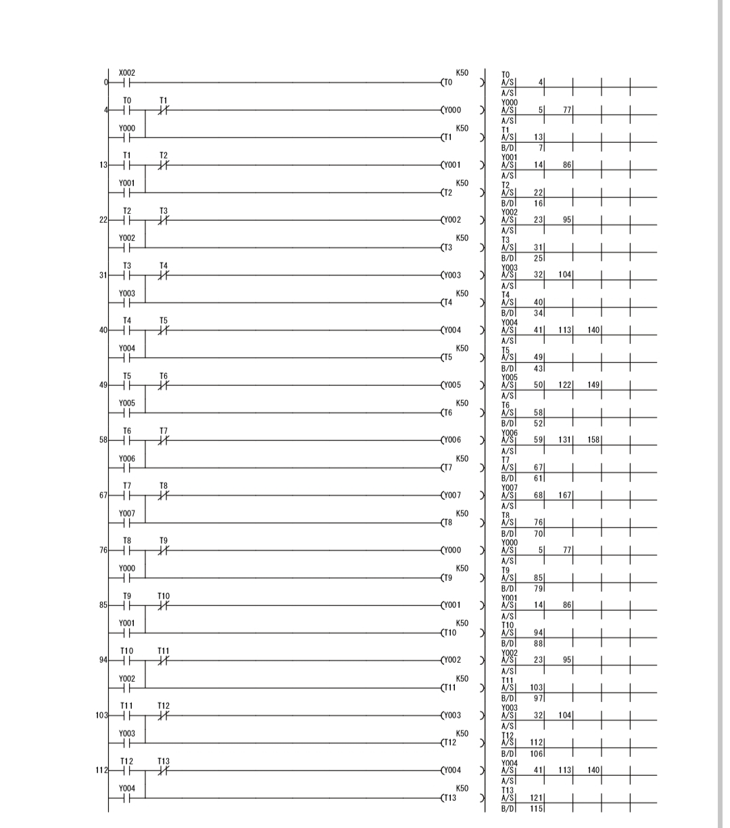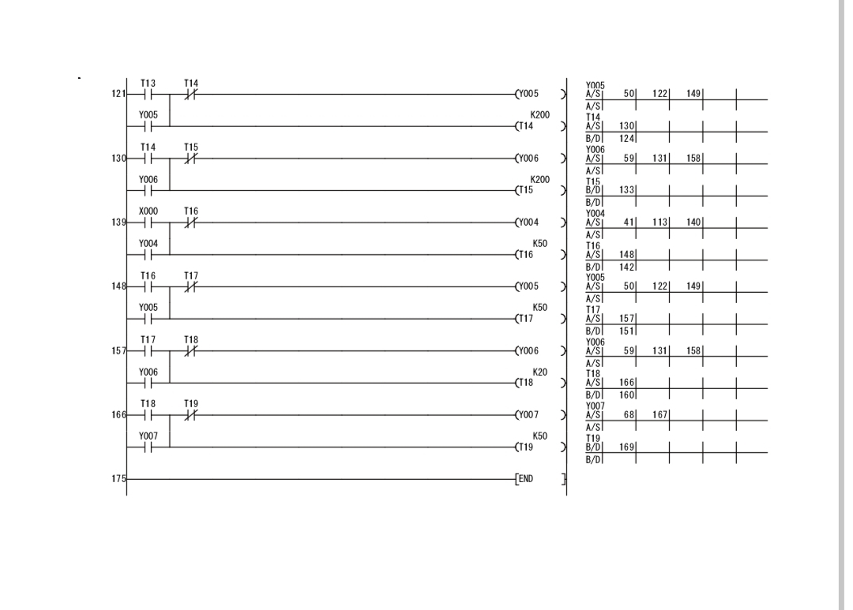

**4.6 INSTALLATION OF THE COMPONENTS**

At this stage, we shall be treating the steps taken in arranging and placing the components in the housing structure/casing:

1. The PLC was placed inside the casing and marked out using a pencil.
2. The terminals were placed in the casing in their desired arrangement and marked using a pencil.
3. The lamps were also arranged in the casing and marked using a pencil.
4. We checked to ensure the casing could close effectively with the current arrangement made.
5. We glued the PLC to the casing using gum.
6. We allowed some moments for the PLC to stick firmly to the casing.
7. We drilled a hole in the casing and installed the lamps and the terminals.

**4.7 CONSTRUCTION OF THE CASING**

**4.8 WIRING THE COMPONENTS**

In this stage, we made use of the jumper wires which was selected in chapter 3 to carry out our wiring operation. The wires were cut using pliers and soldered at the required points. To ensure clean soldering, excessive leads were removed from the soldered points.

**4.9 COMMISSIONING OF THE PROJECT**

The following steps were taken in the commissioning of the project:

1. The power cables was connected
2. The network cable was connected
3. The PC was turned ON.
4. The programs were run on the project and its response was observed.
5. The project was properly shut down.

## 4.10 TESTS AND RESULTS

The following tests were carried out and the following results were obtained:

**Table 4.1: Test and Result**

|  |  |  |  |  |
| --- | --- | --- | --- | --- |
| **Test** | **Aim** | **Equipment**  **used** | **Result** | **Conclusion** |
| Firmness test. | To ensure all components were tightly installed in the casing | Slight pulling | All the components were firmly installed as none pulled | All components were properly installed |
| Open Circuit test | To ensure there is no open circuit on the wiring done from one component to another | Digital Multimeter | All the test points read R>1Ω | There is no open circuit in the connection therefore the connection was properly done |
| Insulation test | To ensure there is no leakage current from any of the components to the casing of the project | Digital Multimeter | There was no continuity at all the test point which means there is no leakage current | There is no leakage current therefore insulation is perfect. |
| Short Circuit Test | To ensure there is no short circuit on the wiring done from one component to another. | Digital Multimeter | All the test points read R>1Ω. | There is no short circuit in the connection therefore the connection was properly done |
| Operation test | To ensure the system was working efficiently | The system was powered ON and the programs were run and were observed on the project. | Operated as required | System is in good operating condition. |

**4.11 PICTURES OF THE AUTOMATIC BOILER SYSTEM**

**Table 4.2: Bill of engineering material**

|  |  |  |  |  |
| --- | --- | --- | --- | --- |
| **S/N** | **DESCRIPTION OF ITEM** | **QTY** | **UNIT PRICE (N)** | **TOTAL PRICE**  **(N)** |
| 1 | MITSUBISHI FX-1s-20MR 001 | 1 | 150,000.00 | 150,000.00 |
| 2 | Switch | 3 | 150.00 | 450.00 |
| 3 | Indicator Lamp | 8 | 200.00 | 16000.00 |
| 4 | Voltage Regulator | 1 | 500.00 | 500.00 |
| 5 | Casing | 1 | 200,000.00 | 200,000.00 |
| 6 | Power supply (power pack) | 1 | 8,000.00 | 8,000.0 |
| **7** | **Pump** | 1 | **30,0000** | **30,000** |
|  |  |  |  |  |
|  |  |  |  |  |
|  | **TOTAL** |  | **174,000.00** | **190,000.00** |

**4.12 PRECAUTIONS FOR USING THE TRAINING KIT**

i. Ensure to study and understand every equipments manual before commencing its use.

ii. Ensure to use the automatic boiler in Safe and well lit environments

iii. Be cautious of hazards possible in the use of the automatic boiler system.

iv. Ensure adequate care is applied in the use of the equipment to avoid damaging it.

v. Ensure use of proper power source in operating the automatic boiler system.

vi. Keep the equipment in clean area and away from moisture atmosphere to prevent insulation problem.

vii. Do not take any maintenance work or operation without the presence of the Lab Technician.

viii. When maintaining, turn off the main power to prevent electric shock.

**4.13 PRECAUTIONS TAKEN IN THE CONSTRUCTION OF THE AUTOMATIC BOILER SYSTEM**

i. We ensured accurate measurements were taken before cutting the material

ii. We ensured to work only in safe environment while taking safety rules into great consideration.

iii. We ensure appropriate care was taken in cutting and in joining the casing material to reduce wastage of material, obtain better look and improve efficiency.

iv. We ensured proper connection of the components.

1. We applied great care in sizing the components in its casing to ensure the components fit and space isn’t wasted.
2. We ensured to follow the operational manual of all the equipment
3. We ensured to seek technical advice and assistance whenever necessary all through the construction process.
4. We ensure to consider reliability and safety of the users and environment in the construction of the project.